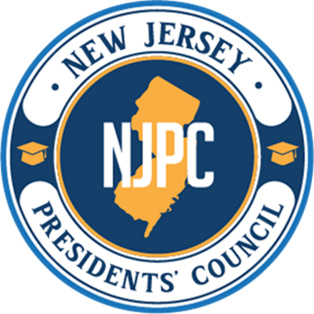 | ACADEMIC ISSUES COMMITTEE  NEW ACADEMIC DEGREE PROGRAM PROPOSAL CHECKLIST

☐ | New Academic Degree Program | ☐ | Changing the Degree Designation of an Existing Program

Institution: | Click or tap here to enter text.
Programmatic Mission: | Choose an item.
Program Title: | Click or tap here to enter text.
Degree Designation: | Click or tap here to enter text.

DESCRIPTION  Please use the following sequence to assemble the proposal in a single, bookmarked PDF document. | Check to confirm
- Program Announcement (cover letter, cover page, summary) | ☐
- Standards for New Academic Degree Programs Form | ☐
- Consultant’s Curriculum Vitae | ☐
- Consultant Report | ☐
- Site visit: Choose visit type | ☐
- Date of site visit: Click or tap to enter a date.
- Submission date: Click or tap to enter a date.
- Response to Consultant’s Report | ☐
- Governing Board Resolution | ☐
- Date of resolution: Click or tap to enter a date.
- Exceeding Programmatic Mission Form | ☐ | or | ☐ | N/A
- 3+1 Bridge Program letter of support from baccalaureate institution | ☐ | or | ☐ | N/A
- Institutional Responses to Program Announcement
- Copies of letters from responding colleges and universities | ☐ | or | ☐ | N/A
- Statement of no concerns | ☐ | or | ☐ | N/A
- Institutions expressing a concern: | ☐ | or | ☐ | N/A
- Responses to institutions expressing a concern | ☐ | or | ☐ | N/A
- Information about reconciliation efforts | ☐ | or | ☐ | N/A

Name: Click or tap here to enter text. | Title: Click or tap here to enter text.
Email: Click or tap here to enter text. | Phone: Click or tap here to enter text.
Signature: | Date: Click or tap to enter a date.

